Lab 10: Implementation of block world Problem

**Aim:** - To implement block world problem using python.

**Source Code for the block world problem implementation using python: -**

class PREDICATE:

  def __str__(self):

    pass

  def __repr__(self):

    pass

  def __eq__(self, other) :

    pass

  def __hash__(self):

    pass

  def get_action(self, world_state):

    pass

#OPERATIONS - Stack, Unstack, Pickup, Putdown

class Operation:

  def __str__(self):

    pass

  def __repr__(self):

    pass

  def __eq__(self, other) :

    pass

  def precondition(self):

    pass

  def delete(self):

    pass

  def add(self):

    pass

class ON(PREDICATE):

  def __init__(self, X, Y):

    self.X = X

    self.Y = Y

  def __str__(self):

    return "ON({X},{Y})".format(X=self.X,Y=self.Y)

  def __repr__(self):

    return self.__str__()

  def __eq__(self, other) :

    return self.__dict__ == other.__dict__ and self.__class__ == other.__class__

  def __hash__(self):

      return hash(str(self))

  def get_action(self, world_state):

    return StackOp(self.X,self.Y)

class ONTABLE(PREDICATE):

  def __init__(self, X):

    self.X = X

  def __str__(self):

    return "ONTABLE({X})".format(X=self.X)

  def __repr__(self):

    return self.__str__()

  def __eq__(self, other) :

    return self.__dict__ == other.__dict__ and self.__class__ == other.__class__

  def __hash__(self):

      return hash(str(self))

  def get_action(self, world_state):

    return PutdownOp(self.X)

class CLEAR(PREDICATE):

  def __init__(self, X):

    self.X = X

  def __str__(self):

    return "CLEAR({X})".format(X=self.X)

    self.X = X

  def __repr__(self):

    return self.__str__()

  def __eq__(self, other) :

    return self.__dict__ == other.__dict__ and self.__class__ == other.__class__

  def __hash__(self):

    return hash(str(self))

  def get_action(self, world_state):

    for predicate in world_state:

      #If Block is on another block, unstack

      if isinstance(predicate,ON) and predicate.Y==self.X:

        return UnstackOp(predicate.X, predicate.Y)

    return None

class HOLDING(PREDICATE):

  def __init__(self, X):

    self.X = X

  def __str__(self):

    return "HOLDING({X})".format(X=self.X)

  def __repr__(self):

    return self.__str__()

  def __eq__(self, other) :

    return self.__dict__ == other.__dict__ and self.__class__ == other.__class__

  def __hash__(self):

    return hash(str(self))

  def get_action(self, world_state):

    X = self.X

    #If block is on table, pick up

    if ONTABLE(X) in world_state:

      return PickupOp(X)

    #If block is on another block, unstack

    else:

      for predicate in world_state:

        if isinstance(predicate,ON) and predicate.X==X:

          return UnstackOp(X,predicate.Y)

class ARMEMPTY(PREDICATE):

  def __init__(self):

    pass

  def __str__(self):

    return "ARMEMPTY"

  def __repr__(self):

    return self.__str__()

  def __eq__(self, other) :

    return self.__dict__ == other.__dict__ and self.__class__ == other.__class__

  def __hash__(self):

    return hash(str(self))

  def get_action(self, world_state=[]):

    for predicate in world_state:

      if isinstance(predicate,HOLDING):

        return PutdownOp(predicate.X)

    return None

class StackOp(Operation):

  def __init__(self, X, Y):

    self.X = X

    self.Y = Y

  def __str__(self):

    return "STACK({X},{Y})".format(X=self.X,Y=self.Y)

  def __repr__(self):

    return self.__str__()

  def __eq__(self, other) :

    return self.__dict__ == other.__dict__ and self.__class__ == other.__class__

  def precondition(self):

    return [ CLEAR(self.Y) , HOLDING(self.X) ]

  def delete(self):

    return [ CLEAR(self.Y) , HOLDING(self.X) ]

  def add(self):

    return [ ARMEMPTY() , ON(self.X,self.Y) ]

class UnstackOp(Operation):

  def __init__(self, X, Y):

    self.X = X

    self.Y = Y

  def __str__(self):

    return "UNSTACK({X},{Y})".format(X=self.X,Y=self.Y)

  def __repr__(self):

    return self.__str__()

  def __eq__(self, other) :

    return self.__dict__ == other.__dict__ and self.__class__ == other.__class__

  def precondition(self):

    return [ ARMEMPTY() , ON(self.X,self.Y) , CLEAR(self.X) ]

  def delete(self):

    return [ ARMEMPTY() , ON(self.X,self.Y) ]

  def add(self):

    return [ CLEAR(self.Y) , HOLDING(self.X) ]

class PickupOp(Operation):

  def __init__(self, X):

    self.X = X

  def __str__(self):

    return "PICKUP({X})".format(X=self.X)

  def __repr__(self):

    return self.__str__()

  def __eq__(self, other) :

    return self.__dict__ == other.__dict__ and self.__class__ == other.__class__

  def precondition(self):

    return [ CLEAR(self.X) , ONTABLE(self.X) , ARMEMPTY() ]

  def delete(self):

    return [ ARMEMPTY() , ONTABLE(self.X) ]

  def add(self):

    return [ HOLDING(self.X) ]

class PutdownOp(Operation):

  def __init__(self, X):

    self.X = X

  def __str__(self):

    return "PUTDOWN({X})".format(X=self.X)

  def __repr__(self):

    return self.__str__()

  def __eq__(self, other) :

    return self.__dict__ == other.__dict__ and self.__class__ == other.__class__

  def precondition(self):

    return [ HOLDING(self.X) ]

  def delete(self):

    return [ HOLDING(self.X) ]

  def add(self):

    return [ ARMEMPTY() , ONTABLE(self.X) ]

def isPredicate(obj):

  predicates = [ON, ONTABLE, CLEAR, HOLDING, ARMEMPTY]

  for predicate in predicates:

    if isinstance(obj,predicate):

      return True

  return False

def isOperation(obj):

  operations = [StackOp, UnstackOp, PickupOp, PutdownOp]

  for operation in operations:

    if isinstance(obj,operation):

      return True

  return False

def arm_status(world_state):

  for predicate in world_state:

    if isinstance(predicate, HOLDING):

      return predicate

  return ARMEMPTY()

class GoalStackPlanner:

  def __init__(self, initial_state, goal_state):

    self.initial_state = initial_state

    self.goal_state = goal_state

  def get_steps(self):

    #Store Steps

    steps = []

    #Program Stack

    stack = []

    #World State/Knowledge Base

    world_state = self.initial_state.copy()

    #Initially push the goal_state as compound goal onto the stack

    stack.append(self.goal_state.copy())

    #Repeat until the stack is empty

    while len(stack)!=0:

      #Get the top of the stack

      stack_top = stack[-1]

      #If Stack Top is Compound Goal, push its unsatisfied goals onto stack

      if type(stack_top) is list:

        compound_goal = stack.pop()

        for goal in compound_goal:

          if goal not in world_state:

            stack.append(goal)

      #If Stack Top is an action

      elif isOperation(stack_top):

        #Peek the operation

        operation = stack[-1]

        all_preconditions_satisfied = True

        #Check if any precondition is unsatisfied and push it onto program stack

        for predicate in operation.delete():

          if predicate not in world_state:

            all_preconditions_satisfied = False

            stack.append(predicate)

        #If all preconditions are satisfied, pop operation from stack and execute it

        if all_preconditions_satisfied:

          stack.pop()

          steps.append(operation)

          for predicate in operation.delete():

            world_state.remove(predicate)

          for predicate in operation.add():

            world_state.append(predicate)

      #If Stack Top is a single satisfied goal

      elif stack_top in world_state:

        stack.pop()

      #If Stack Top is a single unsatisfied goal

      else:

        unsatisfied_goal = stack.pop()

        #Replace Unsatisfied Goal with an action that can complete it

        action = unsatisfied_goal.get_action(world_state)

        stack.append(action)

        #Push Precondition on the stack

        for predicate in action.precondition():

          if predicate not in world_state:

            stack.append(predicate)

    return steps

if __name__ == '__main__':

  initial_state = [

    ON('B','A'),

    ON('C','B'),

    ONTABLE('A'),ONTABLE('D'),

    CLEAR('C'),CLEAR('D'),

    ARMEMPTY()

  ]

  goal_state = [

    ON('B','D'),ON('C','A'),

    ONTABLE('D'),ONTABLE('A'),

    CLEAR('B'),CLEAR('C'),

    ARMEMPTY()

  ]

  goal_stack = GoalStackPlanner(initial_state=initial_state, goal_state=goal_state)

  steps = goal_stack.get_steps()

  print(steps)

**Output:-**

**[UNSTACK(C,B), PUTDOWN(C), UNSTACK(B,A), PUTDOWN(B), PICKUP(C), STACK(C,A), PICKUP(B), STACK(B,D)]**

**Screenshots:-**

Output:-

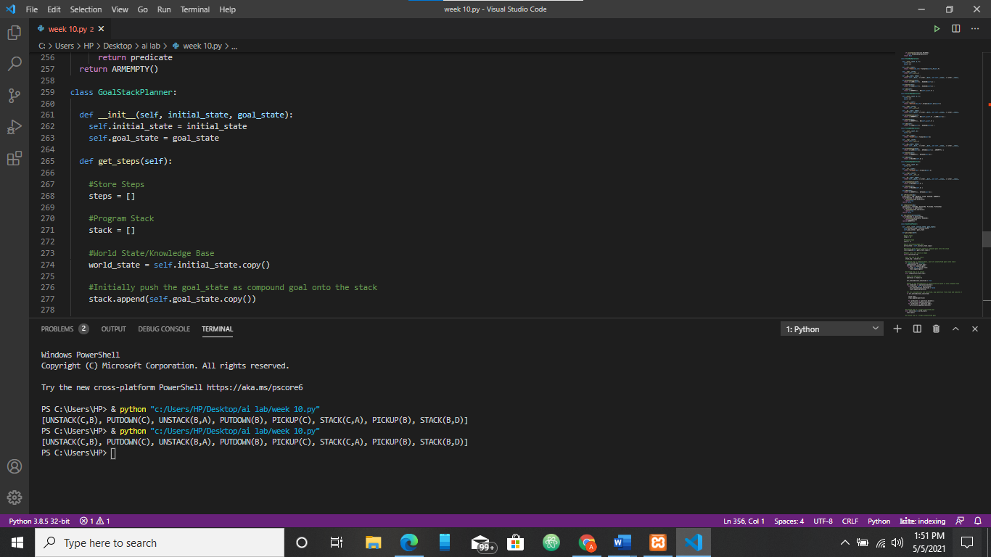

**Result: -** Successfully implemented and executed block world problem using python.